**System Design Document**

**For**

**Mental Health Application**

Team member:

* Lizzy Jackson
* Garðar Benediktsson
* Harrison Dinius
* Jason Hansen
* Gabrielle Stoney

|  |  |
| --- | --- |
| Version/Author | Date |
|  | 09/29/2020 |
| Lizzy Jackson, Garðar Benediktsson | 10/28/2020 |
| Lizzy Jackson, Garðar Benediktsson | 2/17/2021 |
| Gabrielle Stoney, Garðar Benediktsson, Lizzy Jackson | 2/18/2021 |
| Lizzy Jackson, Garðar Benediktsson | 4/12/2021 |

TABLE OF CONTENT

**1 INTRODUCTION 3**

1.1 Purpose and Scope 3

1.2 Project Executive Summary 3

*1.2.1 System Overview 3*

*1.2.2. Design Constraints 3*

*1.2.3 Future Contingencies 3*

1.3 Glossary 3

**2 HUMAN-MACHINE INTERFACE 4**

*2.1 Inputs 4*

*2.2 Outputs 7*

**3 DETAILED DESIGN 8**

3.1 Software Detailed Design 8

SYSTEM DESIGN DOCUMENT

# INTRODUCTION

## Purpose and Scope

The purpose of this document is to visualize the design of the user interface for the Mental Health Application.

## Project Executive Summary

This document describes the system requirements, operating environment, system and subsystem architecture, files and database design, input formats, output layouts, detailed design, processing logic, and external interfaces for the Mental Health Application. All parts are described in detail and evaluated in their respective places in this document.

### System Overview

### The goal of the Mental Health Application system is to collectdata from the user’s communications on different social media platforms and learn who their closest friends based off their data. This is achieved by having the user request their .json files from a social media platform such as Facebook, Snapchat and Instagram. The data from all social media platforms are then passed through an algorithm in order to create a list of a user's closest friends and organizes those friends into tiers. The algorithm will then compare who the users friends on social media is to the contacts save on their phone. After processing the data, the tiers of friends are exported to a CSV file for future updates by the algorithm. The user interface displays the created tiers to the user. Furthermore, the user interface will send notifications when a user's tier of friends changes.Design Constraints

The team is making several assumptions when developing this project, which are as follows:

* User has an iPhone updated to the latest version of iOS.
* User must have at least one contact in their contact logs.
* User allows application to access data from to at least one social media platform from Facebook, Instagram, and Snapchat.

## Glossary

Communication/Communicating: For the purposes of this document, communication is a broad term used to refer specifically to interactions on a social media platform such as likes, shares, and personal message.

# HUMAN-MACHINE INTERFACE

This section provides the detailed design of the system and subsystem inputs and outputs relative to the user/operator. Any additional information may be added to this section and may be organized according to whatever structure best presents the operator input and output designs. Depending on the particular nature of the project, it may be appropriate to repeat these sections at both the subsystem and design module levels. Additional information may be added to the subsections if the suggested lists are inadequate to describe the project inputs and outputs.

## Inputs

The application requires a user to request a .json file from one or all social media platforms (Facebook, Instagram, and Snapchat). A .json fire then needs to be put into the same file at the project. Downloading a users own personal .json file guarantees the users privacy as it is their own data being collected. The user can input their own weights for each social media interaction and platform for their own research purposes. The application needs the user’s permission to be able to access their contacts. to make the connection between known people and those they communicate with on social media. (Figure 3.1). This is done to allow the user to control their privacy. The application will also request input via a survey for interaction impacts on a user.

**Application Layout:**

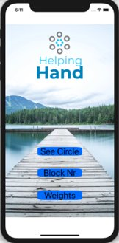

Figure 1.1 - Welcome screen of application

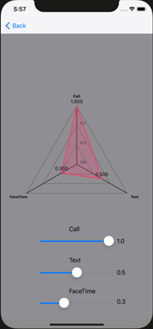

Figure 1.3 - Allows user to change weight (importance) of various forms of communication.

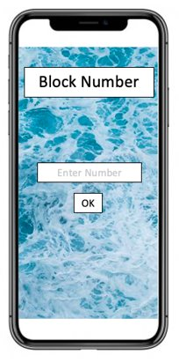

Figure 1.4 - Application allows user to block numbers from being calculated in algorithm.

Figure 3.1 - Requires user to give access to contacts.

## Outputs

The user application will output the names of the contacts that are in the user’s inner circle. The application will run the algorithm to determine which contacts to display (Figure 1.2).

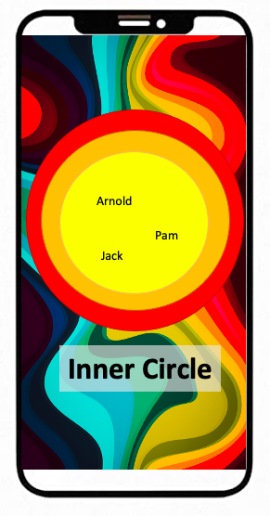

Figure 1.2 - Screen displaying inner circle of numbers application has access to.

# DETAILED DESIGN

## Software Detailed Design

